Intellus Memory Reference error
April 17, 2026

Background
Errors do not seem consistent with customers, but we have the following hints:
- They are more frequent in March (consistent with Spring Forward), and no other time in the year (e.g., no more frequent during Fall Back’s month).
- Logs more often than not seem to show it happen around midnight.
- It seems to happen more when there’s a recorded power outage.
- Every case is usually running a sequence—sometimes a program.

Theory
The key file in this analysis is ProfileEngine.c, and the key function is _ProfileEngine_Is24HourStepExpired.
There is a catch condition on line 1217:1218 (that may or may not be related???), but if the subsequent program’s step is the same as the current program’s last step, then this check will be skipped.
Per lines 1203:1210, around midnight the Intellus has a very brief window where a critical “midnight check” fires. If this check fires, there is a profile cycle counter that fires. However, because PercivalProfiles.c’ battery backed RAM program save calls are asynchronous with what’s happening in ProfileEngine.c, this means that the SavedRunningSequenceStepIndex can desync from the supposed running program and sequence.
I’m not going to pretend to know the code enough to follow what happens after that point, but it’s logical to conclude that this gives the possibility for a program’s pointer to point to obscure places in RAM at this point.

Duplication
Based on the above theory, we were able to follow these steps to consistently replicate the issue. Some of these steps may be redundant, but to be complete they are all listed.
We had one program with two steps: one at midnight and the other at 10:45 a.m. We had a second program with a single step at 10:45 a.m.. These two programs were put in a sequence:
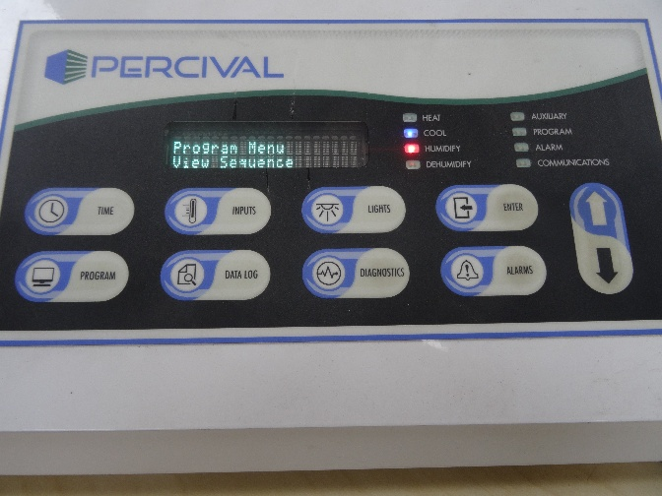
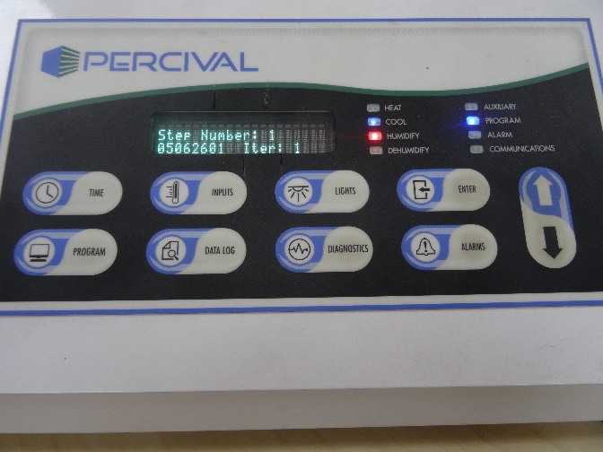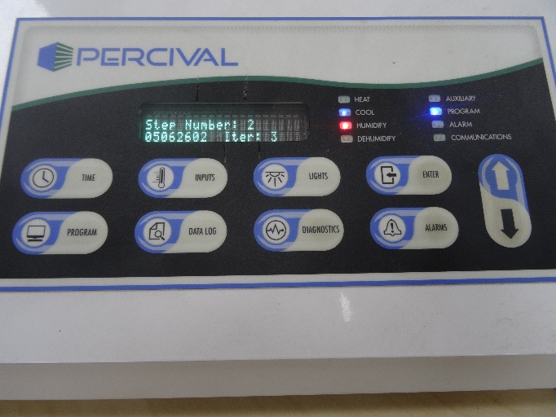
The sequence was started on the first program on iteration 1.
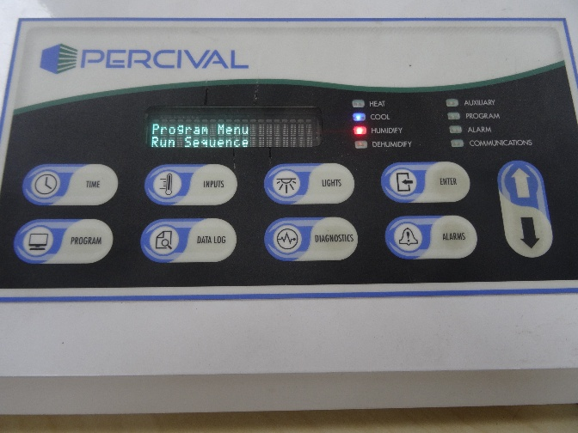
Here are the starting conditions: we’re on program 1, step 1, 1st iteration as expected.
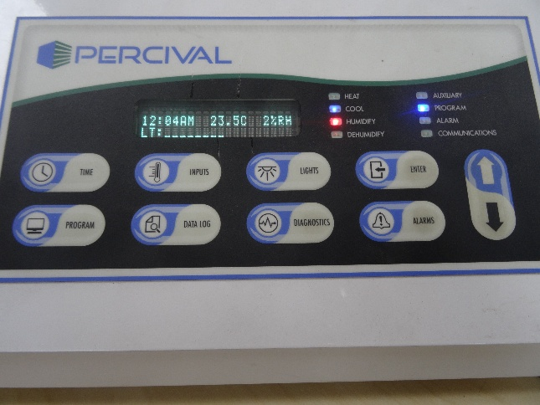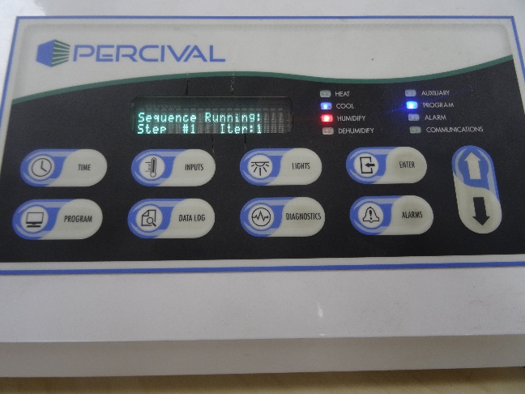
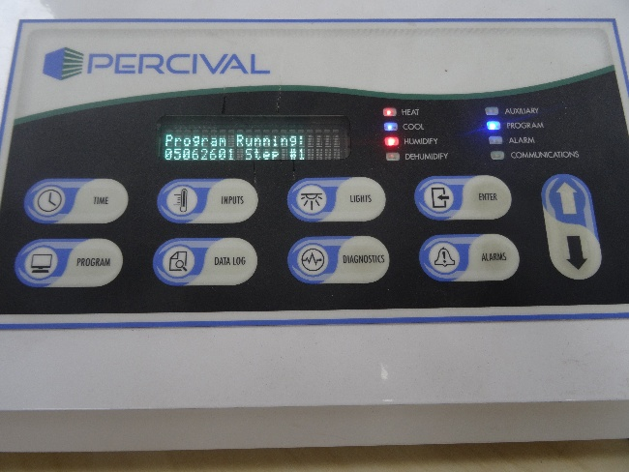
At 10:45, we are now at iteration #1, program #1, step #2—all normal.
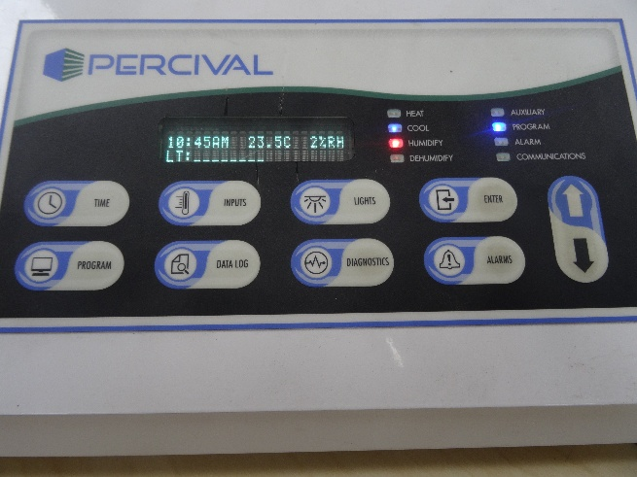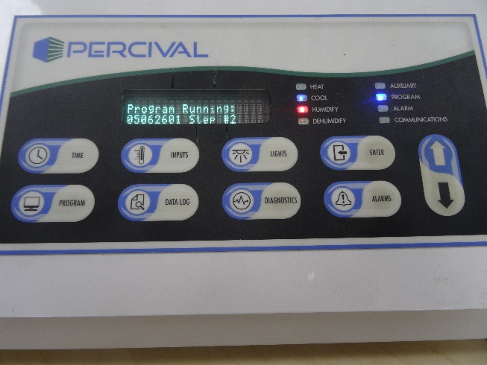
At 11:30 p.m., everything is still nominal.
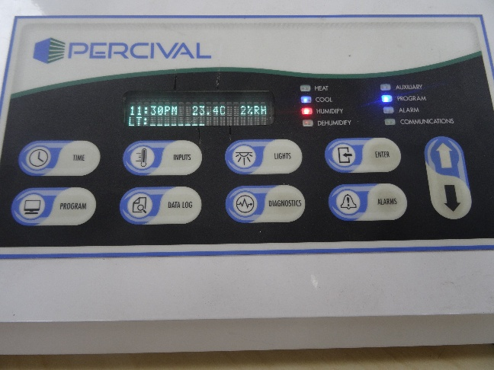
Correct # in sequence and # in program so far.
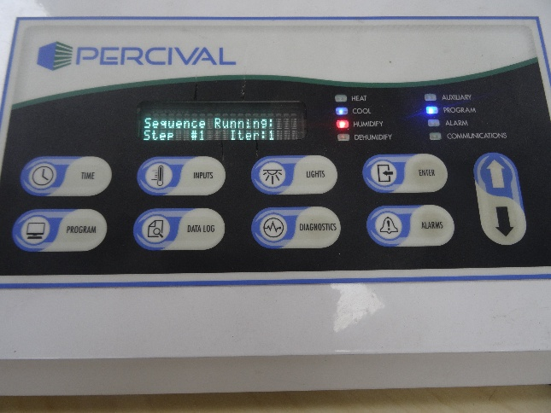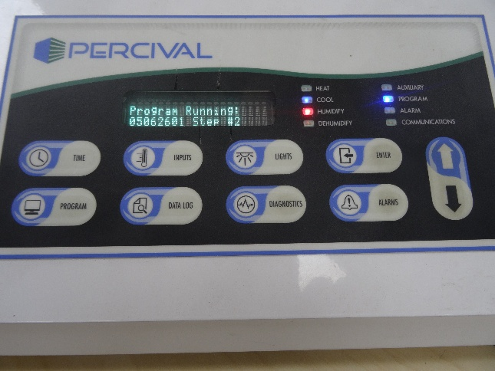
We jump the clock to 2 a.m., mimicking a much more extreme spring forward—or an extended outage on the Intellus that might skip the midnight check.
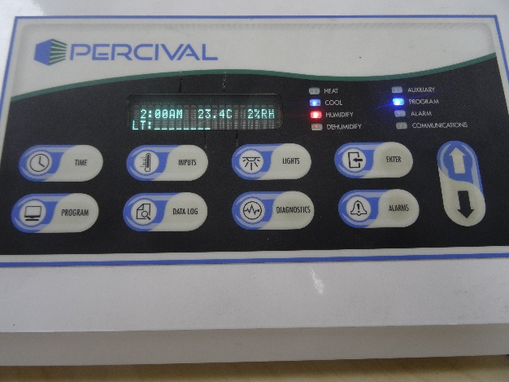
Now, in theory we should either be in program #2, or at the very least back to step #1 of program #1, but instead, we are still in step #2 of program #1.
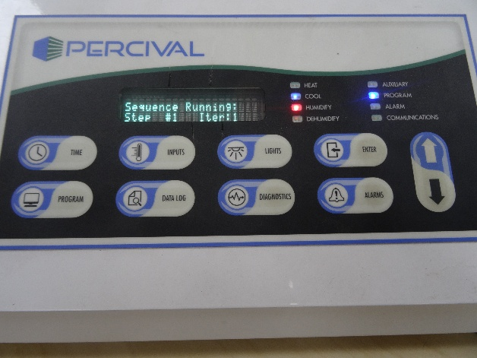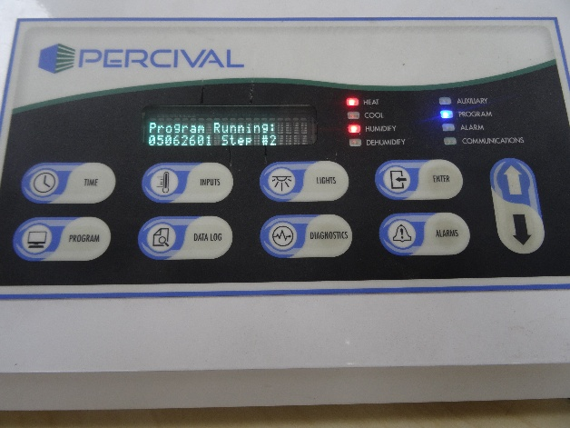
While we are in this weird, desynced state, we wait for midnight.
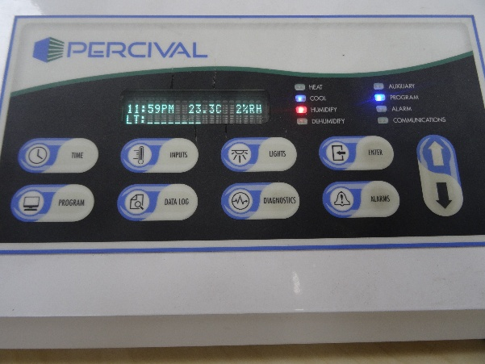
JUST as midnight happens, hard cycle power OFF AND ON to the Intellus (within the same second that 12:00 a.m. shows up):
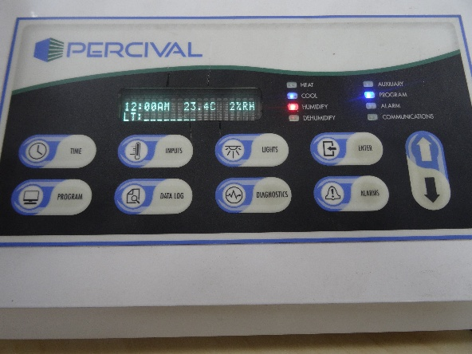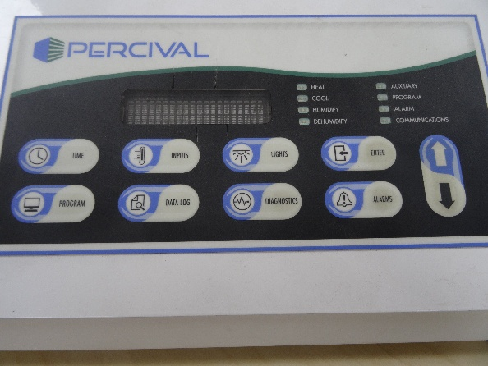
When the Intellus restarts, completely disparate behavior can happen, in this case with this controller, it will restart on the wrong program:
